COLLEGE NAME : DONBOSCOCLEGE (CO-ED), YELAGIRI HLLS

COLLEGE CODE : 358

DEPARTMENT : DEPARTMENT OF COMPUTER APPLICATIONS

TITLE : Courier Management System (CMS)
APPLICATION: COURIERTRACK

TEAM MEMBERS NAME :

S.NO | NAME | REGISTER NUMBER
1 | RUFINA SHARON C | 35824U09076
2 | SANTHIYA P | 35824U09080
3 | SARANYA S | 35824U09081
4 | SOFIA A | 35824U09087
5 | SUJANA VINNARASI E | 35824U09088

ABSTRACT

Courier Management System: COURIERTRACK

Courier and parcel delivery services require accurate tracking, organized shipment records, and efficient coordination between customers, delivery personnel, and courier administrators. However, many small and medium-scale courier organizations still depend on manual records or basic spreadsheets to manage shipment details, customer information, delivery status, and payment records. These traditional methods can lead to data inconsistency, tracking difficulties, delayed updates, and errors in maintaining courier records.

The Courier Management System – COURIERTRACK is a cloud-based application developed using Salesforce to address these challenges. The system is designed to capture, store, and manage courier and shipment information in a centralized and structured manner. It utilizes custom objects such as Customer, Courier, Delivery Agent, and Shipment, along with Master-Detail and Lookup relationships, to maintain data integrity and establish efficient relationships between records.

The application enables the management of courier bookings, shipment details, delivery status, assigned delivery agents, and payment information. Formula fields and automation can be used to calculate delivery charges, track shipment progress, and update relevant records. The system also provides reports and interactive dashboards that help administrators monitor total shipments, delivered and pending parcels, courier status, revenue, and delivery performance.

By transforming manual courier record-keeping into a centralized, automated, and analytics-driven system, COURIERTRACK improves operational efficiency, enhances shipment visibility, and supports better decision-making. The project demonstrates how Salesforce CRM technology can be effectively applied to courier and logistics management by providing a structured platform for managing customers, shipments, deliveries, and performance information.

PROBLEM STATEMENT

In many courier and logistics organizations, especially small and medium-scale businesses, courier records are still maintained manually using notebooks, paper forms, or basic spreadsheets. While these methods may work for a limited number of shipments, they become inefficient as the number of customers, parcels, and deliveries increases. Manual systems lack automation and centralized data management, which creates several operational challenges.

Some of the major problems faced in traditional systems include:

Data duplication and inconsistency

Manual errors in maintaining shipment and customer details

Difficulty in tracking courier and delivery status

No centralized database for storing shipment information

Time-consuming record maintenance and report generation

Difficulty in monitoring delivery agents and assigned shipments

Limited visibility into pending and completed deliveries

Because of these limitations, courier staff and administrators may find it difficult to manage shipments efficiently. Important information such as customer details, parcel details, delivery charges, assigned delivery agent, and delivery status must be manually maintained and updated. This increases the chances of errors and makes it difficult to obtain accurate information about a shipment when required.

Another significant issue is the lack of real-time shipment information. Customers and administrators need timely updates regarding the current status of a courier. However, without a centralized system and automated status management, tracking shipments becomes difficult and time-consuming. This can lead to:

Delayed shipment updates

Difficulty in locating pending deliveries

Poor coordination between staff and delivery agents

Increased chances of incorrect delivery information

Reduced customer satisfaction

Additionally, traditional courier management systems may not provide proper validation rules, security controls, or role-based access. This can result in unauthorized modifications, incomplete records, or loss of important shipment information. Maintaining historical records of customers, shipments, payments, and deliveries also becomes increasingly difficult as the organization grows.

Therefore, there is a strong need for a centralized, automated, and cloud-based Courier Management System like COURIERTRACK, developed using Salesforce. Such a system can provide accurate data storage, structured relationships between objects, automated calculations, secure access, shipment tracking, and powerful reporting capabilities. Implementing this solution can improve courier operations, reduce manual errors, enhance shipment visibility, and support efficient decision-making and customer service.

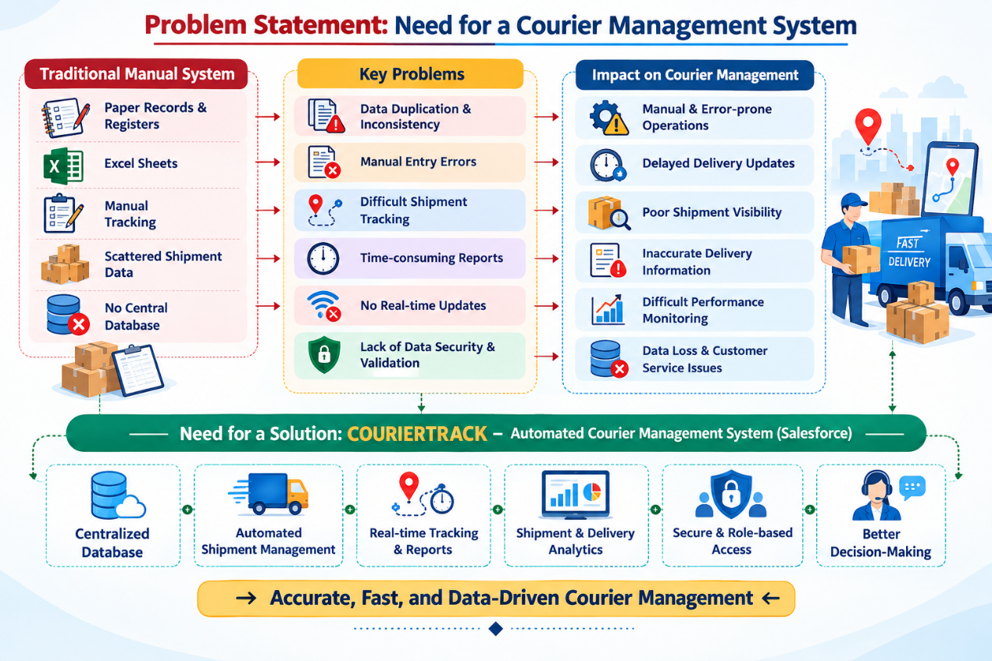

PROPOSED SOLUTION
To overcome the identified challenges, the proposed solution is the development of COURIERTRACK, a cloud-based Courier Management System developed using Salesforce. The application is designed to provide a structured, scalable, and efficient environment for managing customers, courier shipments, deliveries, payments, and tracking information.
Customer Object
This object stores the personal and contact details of customers such as:
- Customer Name
- Phone Number
- Email Address
- Address
- City
- Pincode
- Customer Type
Shipment Object
This object stores the details of each courier or parcel booked by a customer:
- Shipment ID
- Booking Date
- Sender Name
- Receiver Name
- Pickup Address
- Delivery Address
- Parcel Type
- Parcel Weight
- Delivery Charges
- Expected Delivery Date
- Shipment Status
A Master-Detail relationship can be established between Customer (Master) and Shipment (Detail). This allows related shipment records to be managed efficiently and supports Roll-Up Summary Fields for calculating values such as total shipments and total delivery charges for each customer.
Additionally, Lookup relationships can be used to connect:
- Shipment to Delivery Agent
- Shipment to Branch
- Shipment to Payment
Delivery Agent Object
This object stores information about the staff responsible for delivering shipments:
- Agent Name
- Phone Number
- Email Address
- Assigned Branch
- Availability Status
- Number of Assigned Shipments
- Completed Deliveries
Payment Object
This object manages payment information related to courier shipments:
- Payment ID
- Shipment
- Payment Date
- Amount
- Payment Method
- Payment Status
The solution also incorporates:
- Validation Rules to ensure accurate customer and shipment data entry
- Formula Fields to calculate delivery charges and other required values
- Reports for analyzing shipments, payments, and delivery performance
- Interactive Dashboards for visual monitoring of courier operations
- Role-based access control for secure management of customer, shipment, and administrative information
- Automation to update shipment status and manage related records efficiently
The application leverages Salesforce's reporting and dashboard capabilities to generate useful insights such as total shipments, delivered shipments, pending shipments, cancelled shipments, revenue generated, and delivery agent performance.
Thus, COURIERTRACK transforms manual courier record-keeping into a structured, automated, and centralized courier management system. It improves shipment tracking, reduces manual errors, enhances operational efficiency, and provides administrators with timely information for effective decision-making.
WORK FLOW DIAGRAM
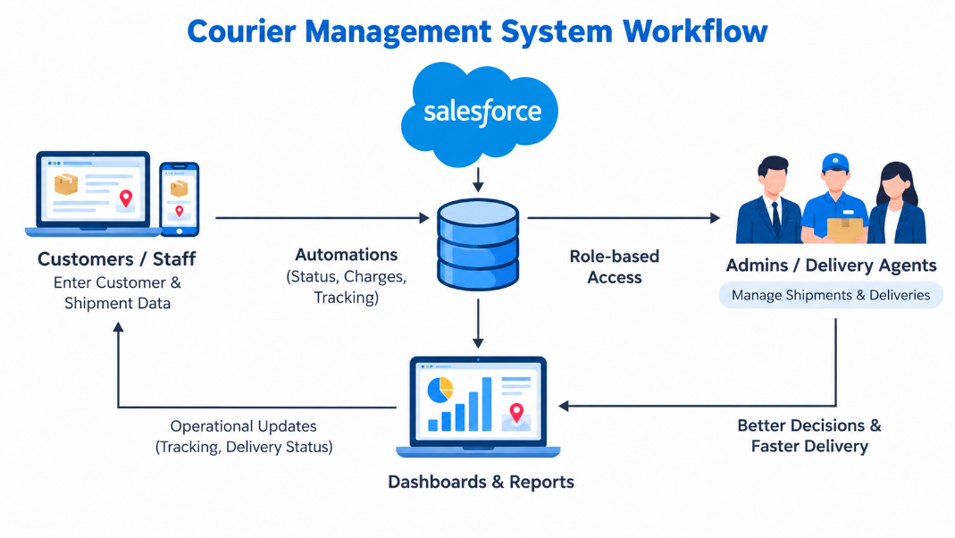

SUMMARY

COURIERTRACK is a comprehensive courier management system built on Salesforce to streamline the management, tracking, and monitoring of courier shipments. The system centralizes customer, shipment, delivery agent, branch, and payment information into structured custom objects, enabling efficient storage and retrieval of courier-related data.
The application uses Master-Detail and Lookup relationships between related objects to maintain data consistency and establish proper connections between customers, shipments, delivery agents, and payments. Formula fields and automation can be used to calculate delivery charges, update shipment status, and reduce the need for manual data entry and calculations.
Through customized reports and interactive dashboards, administrators can monitor shipment volumes, delivered and pending shipments, delivery performance, payment information, and overall courier operations. This provides better visibility into the delivery process and helps staff identify pending shipments and operational issues more efficiently. The cloud-based nature of Salesforce also provides centralized access while supporting security and scalability.
COURIERTRACK not only simplifies courier record management but also improves shipment tracking and operational efficiency. Administrators and delivery staff can access structured information about customers, shipments, delivery status, and payments, reducing manual workload and minimizing errors.
Overall, the application demonstrates how Salesforce CRM technology can be extended beyond traditional customer relationship management into the logistics and courier domain. It bridges the gap between manual courier record-keeping and automated shipment management, providing a structured, secure, and data-driven solution for efficient courier operations.

SCREEN SHORTS
HOME PAGE:

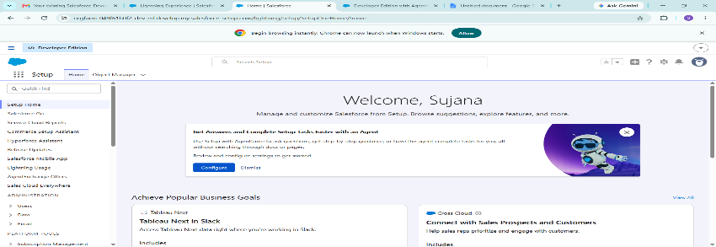

CUSTOMER DETAILS :

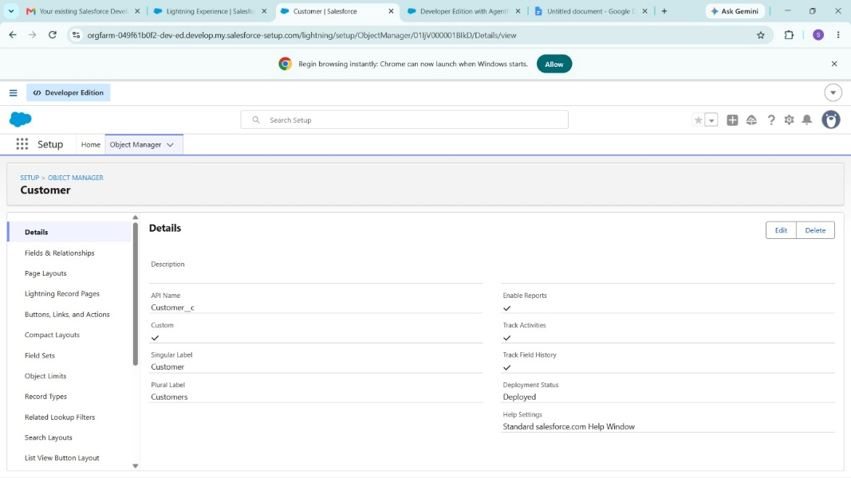

CUSTOMERFLOW:

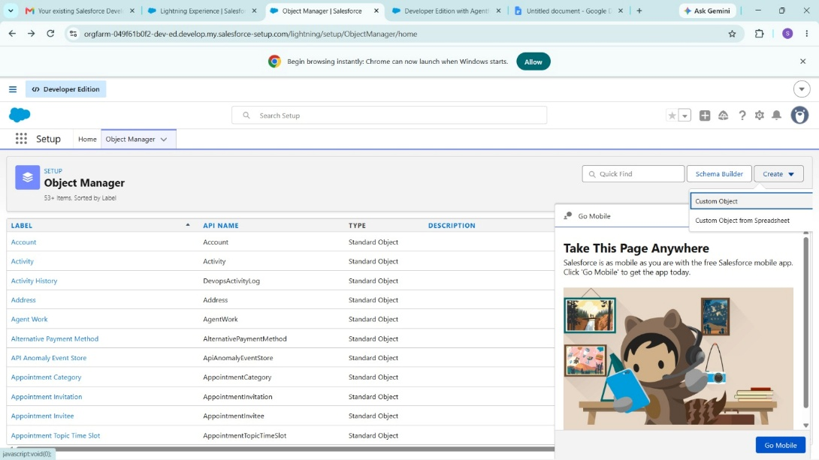

COURIER PERFORMANC PAGE:

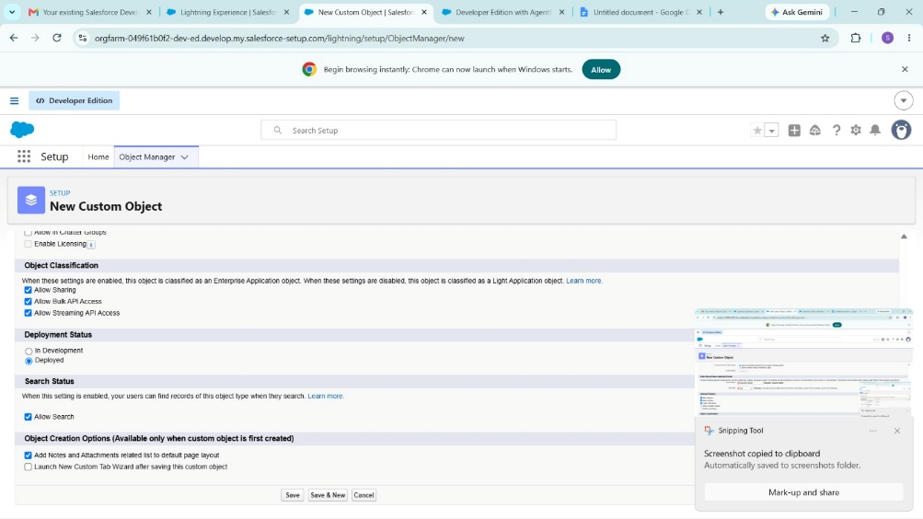

REPORTS PAGE :

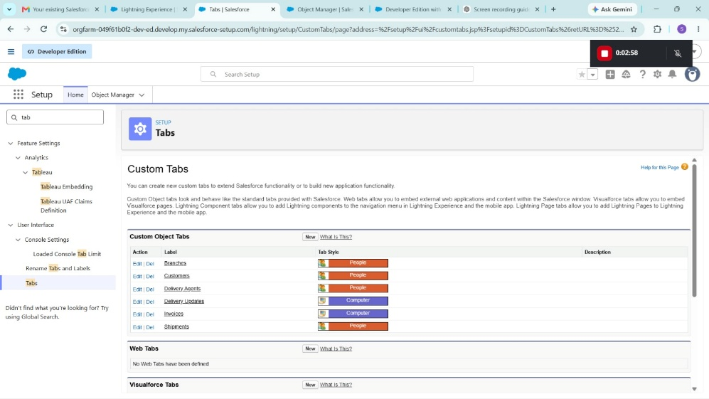

CUSTOMER REPORTS:

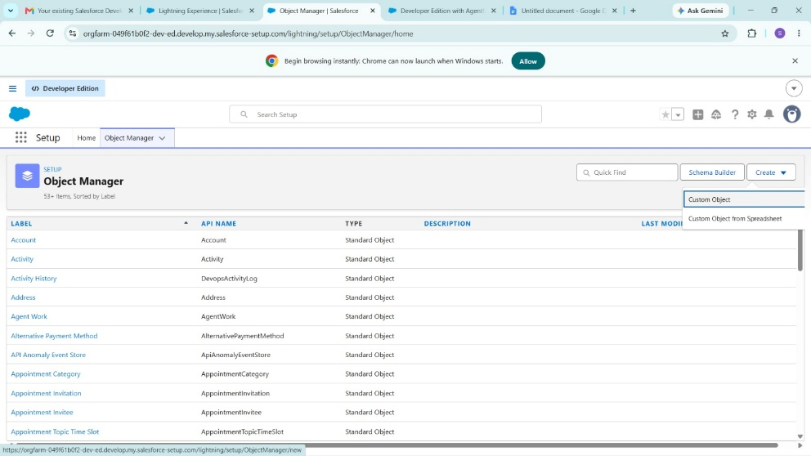

INDIVIDUAL CUSTOMER RECORD :

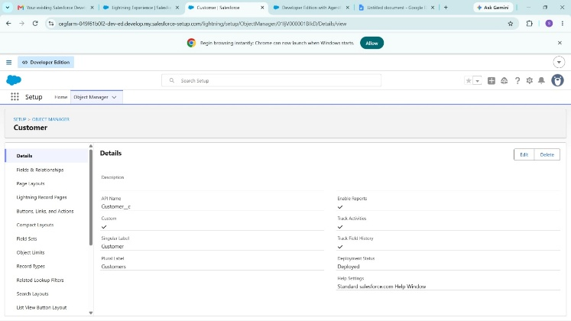

DASHBOARD PAGE :

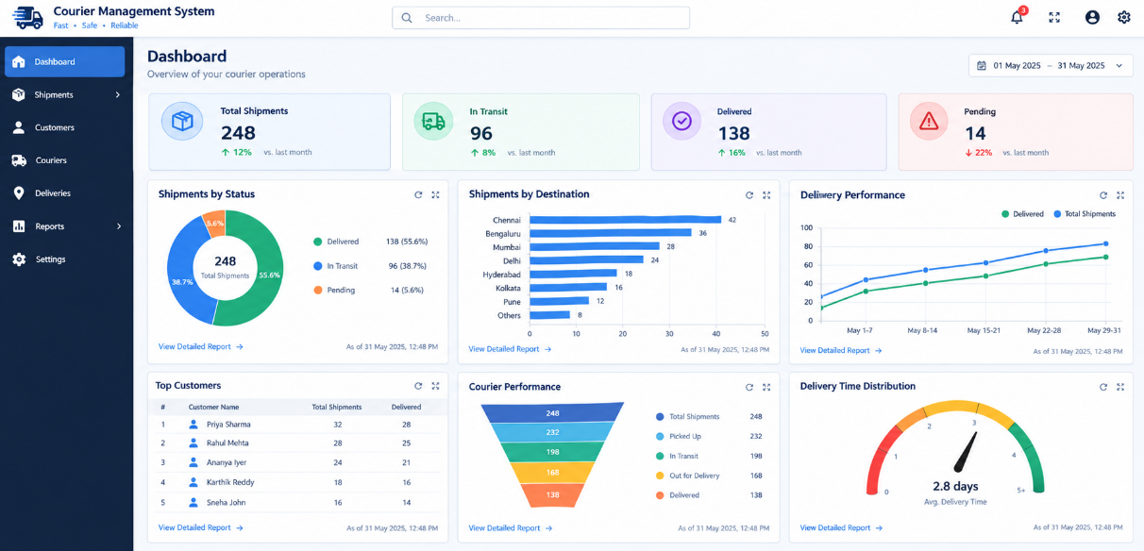

CONCLUSION

The Courier Management System – COURIERTRACK successfully addresses the limitations of traditional courier management methods. By implementing the solution on Salesforce, the project provides a structured, automated, secure, and scalable platform for managing courier operations.
The system provides an efficient method of capturing and managing customer, shipment, delivery agent, branch, and payment information. The use of structured relationships between Salesforce objects helps maintain data consistency, while automation and formula fields reduce manual work and minimize data entry errors.
COURIERTRACK also provides customized reports and dashboards that help administrators monitor shipment status, pending and completed deliveries, payment information, and delivery performance. This improves shipment visibility and enables staff to make timely operational decisions.
The system enhances transparency in courier operations by maintaining centralized and easily accessible records. Role-based access and Salesforce security features help protect important information and ensure that users can access only the data relevant to their responsibilities.
In conclusion, this project demonstrates how modern cloud-based CRM platforms like Salesforce can be effectively utilized in the logistics and courier domain. COURIERTRACK reduces dependency on manual record-keeping, improves operational efficiency, and provides a reliable approach to shipment management and tracking.
The successful implementation of this system highlights the importance of integrating cloud technology, automation, and analytics into courier services, paving the way for faster, more organized, and data-driven courier management in the future.

